Grain-> Bread

Iron -> Weapon

Oil -> Fuel or Moving Ticket

Tea Leaf -> Tea

Wood -> Paper or Construction materials (I will add it to the diagram in the moment)

Bread - used to heal us every day by fixed amount. Without bread you are losing HP

Weapon - used in battles to inflict more damage

Tea - Used to heal yourself by fixed amount. It have fixed limit of uses per day.

Moving ticket - used to move around world.

Hp can be in range from 0% to 100%

Citizen lose 10 HP without bread and gain 2 \* breadQuality HP per day if have one in equipment.

Best bread is eaten on the end of the day of course.

Fuel - is used to move things between companies. You cannot transfer in any way any product between companies without fuel.

It's connected to infrastructure. It's an value that describes regions. The better infrastructure regions have the lower cost of travelling. (and fuel use :P)

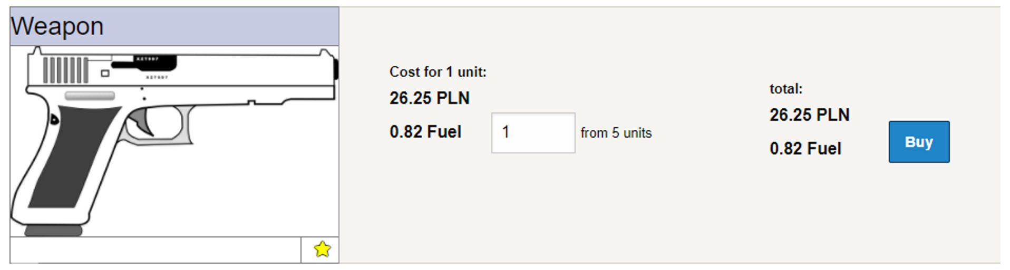

* Construction Points
  + Made from wood and used to build buildings.Certain buildings need certain construction points to be made.
* Selling Power
  + New concept. You cannot buy things directly from companies. First shops need to buy them. Then they can sell things to people. Every shop receives fixed amount of selling power per day (10 is default at the moment) but you can hire shopkeepers to generate this for you. The more shopkeeper the more customers you can have.
* Paper
  + Bought by newspapers and used to sell paid articles

There is also difference on how market is working. You have public and private market offers. Private market offers can be seen only on the company page. Public offers are also visible on marketplace where people can choose the product that they need and compare prices. But publishing products to marketplace may cost national money (like Dollars or Polish Zloty).

Also if you have shop your private offers can be sold only to the people in the same region. Making public offer gives you ability to sell your products nationwide. But in the case of shops I am thinking about fixed fuel price for this action. It’s too OP compared to private offers :D  
  
It’s the main points when it comes to production chains I think.   
Embargoes etc. will come later in some kind of post about diplomatic actions :D. (this is most undercoded part of the game at the moment :<. It’s completed at like 20-50% in terms of programming)